**Business Performance Dashboard**

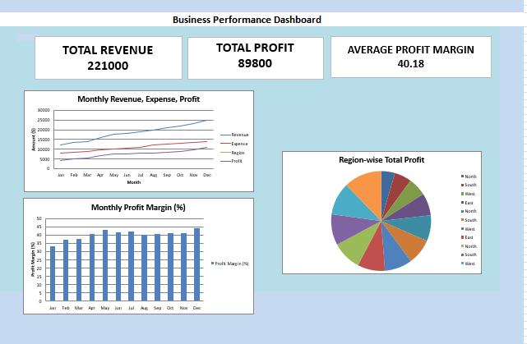

**1. Overview**

This dashboard provides a visual summary of the company’s overall business performance throughout the year. It highlights key financial metrics including total revenue, total profit, and average profit margin, supported by monthly and regional analysis charts.

**2. Purpose**

The main purpose of this dashboard is to:

* Track financial growth and profitability trends.
* Compare monthly revenue, expenses, and profit.
* Analyze profit margin variations across months.
* Evaluate regional performance to identify high and low-performing areas.

**3. Key Performance Indicators (KPIs)**

**a. Total Revenue:** 221,000  
Represents the total sales or income generated during the year.

**b. Total Profit:** 89,800  
Indicates the total earnings after deducting expenses from revenue.

**c. Average Profit Margin:** 40.18%  
Shows the average efficiency of converting revenue into profit.

**4. Dashboard Components**

**a. KPI Cards**

At the top of the dashboard, three KPI cards display the overall totals for revenue, profit, and average profit margin. These provide a quick snapshot of the company’s annual performance.

**b. Monthly Revenue, Expense, and Profit Chart**

This line chart compares monthly trends of:

* **Revenue** (Total earnings)
* **Expense** (Operational costs)
* **Profit** (Revenue minus Expense)

It helps identify months with the highest revenue and profit, as well as periods of increased expenses.

**c. Monthly Profit Margin (%)**

This bar chart displays the profit margin percentage for each month, showing how efficiently the company generated profit relative to revenue. A consistent or increasing trend indicates good cost management and financial stability.

**d. Region-wise Total Profit**

A pie chart visualizes the contribution of different regions (North, South, East, West, etc.) to the total annual profit. It highlights which regions performed best and which may need strategic attention.

**5. Insights**

* The company maintained a **strong profit margin** throughout the year, averaging above 40%.
* **Revenue and profit** show a steady upward trend, indicating consistent business growth.
* Certain regions contribute significantly higher profit shares, suggesting potential for regional focus and expansion.
* The correlation between **increasing revenue and controlled expenses** reflects effective financial management.

**6. Conclusion**

The Business Performance Dashboard provides an at-a-glance view of the company’s financial health and operational efficiency. It can be used by management for decision-making, budgeting, and identifying areas for improvement or investment.